How To Use
minConnect
To help solve and learn Primm’s
and Kruskals algorithms

by
Curtis Stokes

Table of Contents
Introduction 1
Installation 1
Functions 2
Opening the program....................................................2
Using the graphical window............................................2

Introduction

MinConnect is a teaching and solving tool for problems related to minimum connection, this will take a graph of nodes and edges and give you a solution tree in which all the nodes are connected with the minimum possible edge weight. There can be muiltiple valid solutions but this will only provide one. It will also guide you step by step how to work out the problem as it goes to be used as a teaching guide for decision mathematics.

Installation
This software requires no installation as it is packaged as an executable jar file, in order to run this you will need at least the run time version of Java, available free to download from http://www.java.com/en/. The system requirements to run this program is:
- A monitor of at least resolution 1024×768
- At least 1024MB of RAM
- An Intel Pentium 4 2GHz processor or higher

Function

Opening the program
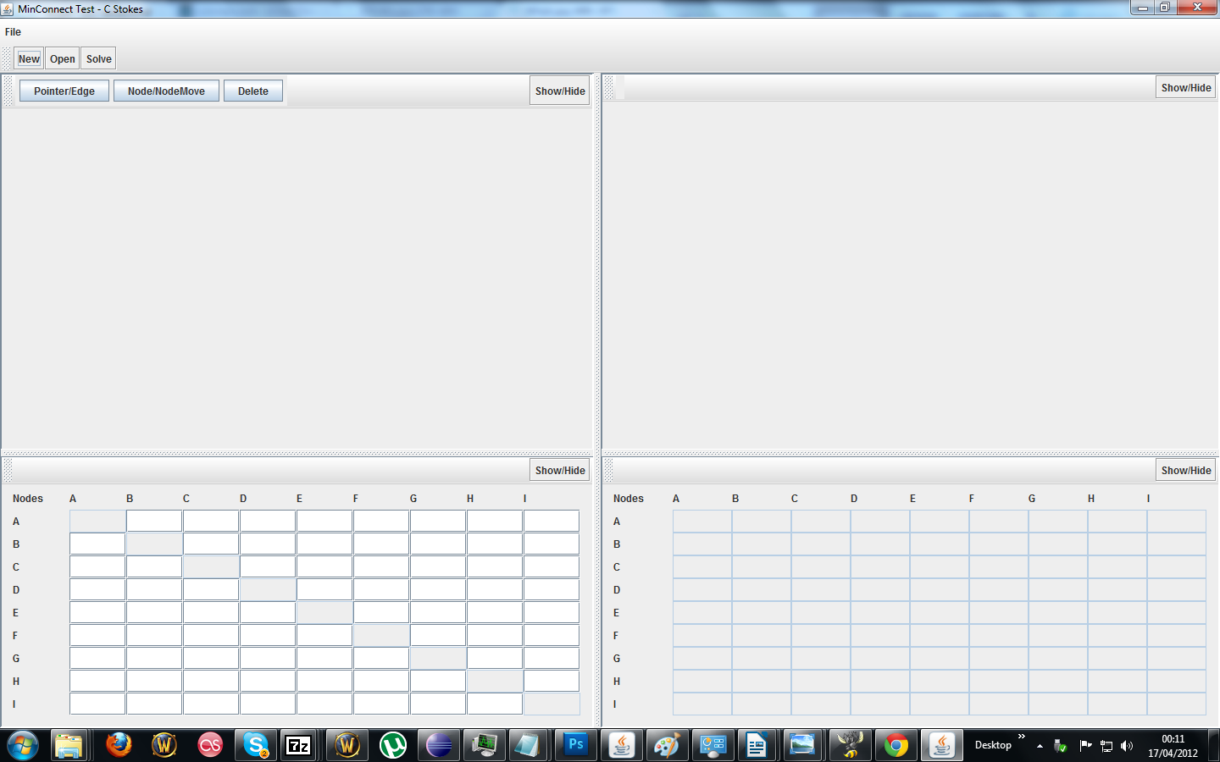
In order to use this app, first double click the executable jar file, this will open up the program that will look something like this:

Drawing the problem
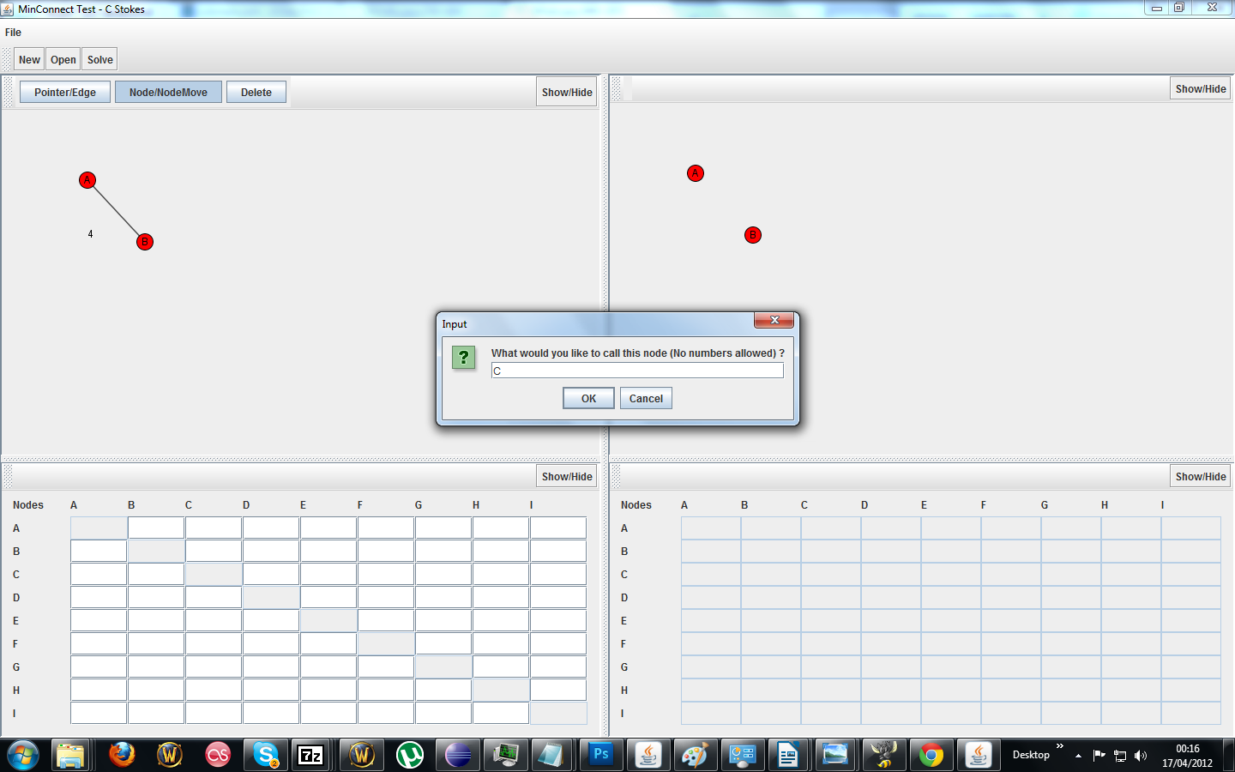
You will then have two options in which you to enter the data you want to use, the first option is to draw the graph in, you should start by adding all the nodes first. To add a node you must ensure the Node/NodeMove toggle button is down and then click anywhere within the top left window, this will bring up a text box asking for a Label which can be any string without numbers. Here is an example of what it should look like:
You can continue to add as many nodes as you want in this way, you can also move around any nodes by clicking them and dragging. Once you are done drawing the nodes you will have to draw the edges, to do this, ensure that the Pointer/Edge button is enabled. When you release the mouse on another edge a pop up will ask you for an edge value, it currently only supports integers. You should note that these will only appear on the top left as the screen Here is what it should look like:

Using the table
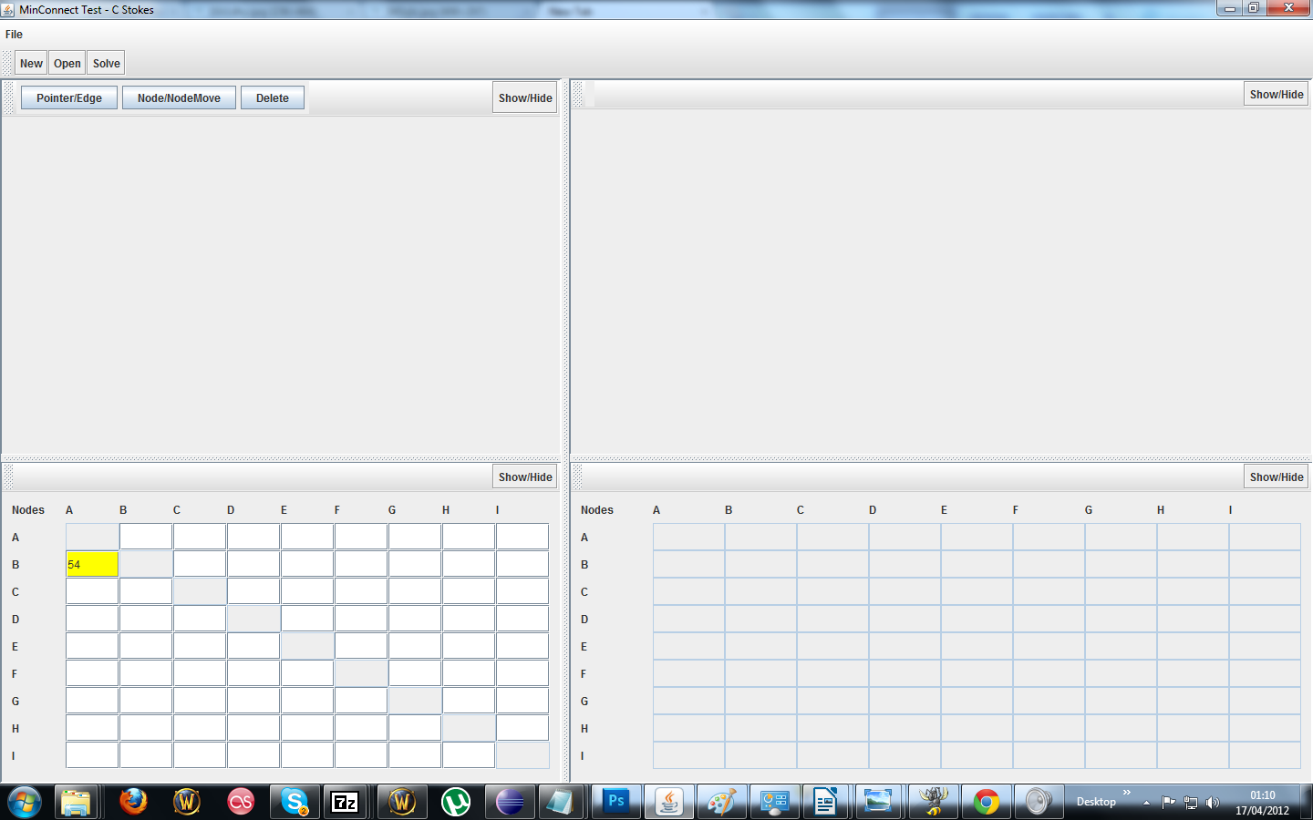
Another option you have for inputting the problem is to use the table panel provided in the bottom left corner, in order to use this you can put the value of the edge between two connections, due to the style of the table there are 2 cells for each possible connection (BD or DB), you can place the value in either one of these and the program will reflect it into the other cell automatically when you press solve. To select a cell click it and it will highlight as shown here, only integer values may be entered

Solving
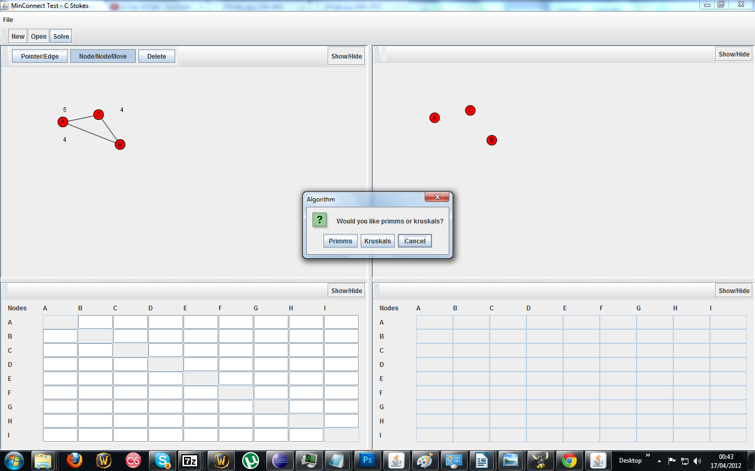
After you have added the desired number of edges and nodes you can then press the solve button at the top. This will open up a choice dialog between which algorithm you want to use. After this there is a Yes/No option for teaching mode disabled, which displays all the output required for D1 mathematics, you should choose no if that is what you are using this software for as it will take you step by step through the solving process. It will look like this

After you have chosen your choices the program will then calculate the minimum connection, and output the steps in the debug window. There is the option to turn step into mode on in the menu :

/TODO: ADD step mode and put screenshot of where to find and screenshot of output

Here is what the GUI will look like without the debug window:
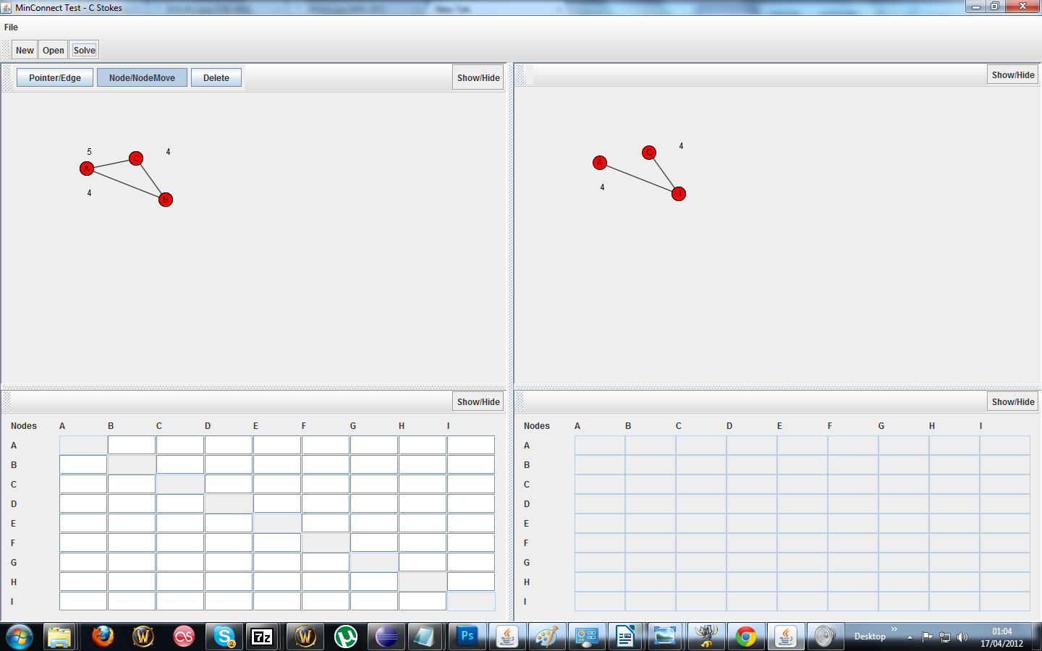
As you can see the solution graph now displays the correct solution for this problem which is 8. If you entered data into the table a graph will still be generated however currently the table is not generated from a graph.

Saving and opening
In order to save a file you should go to the File > save menu, from there you will need to select or create a folder for the problem to be saved in, make sure to save each problem in a separate folder to avoid it over writing previous problems.
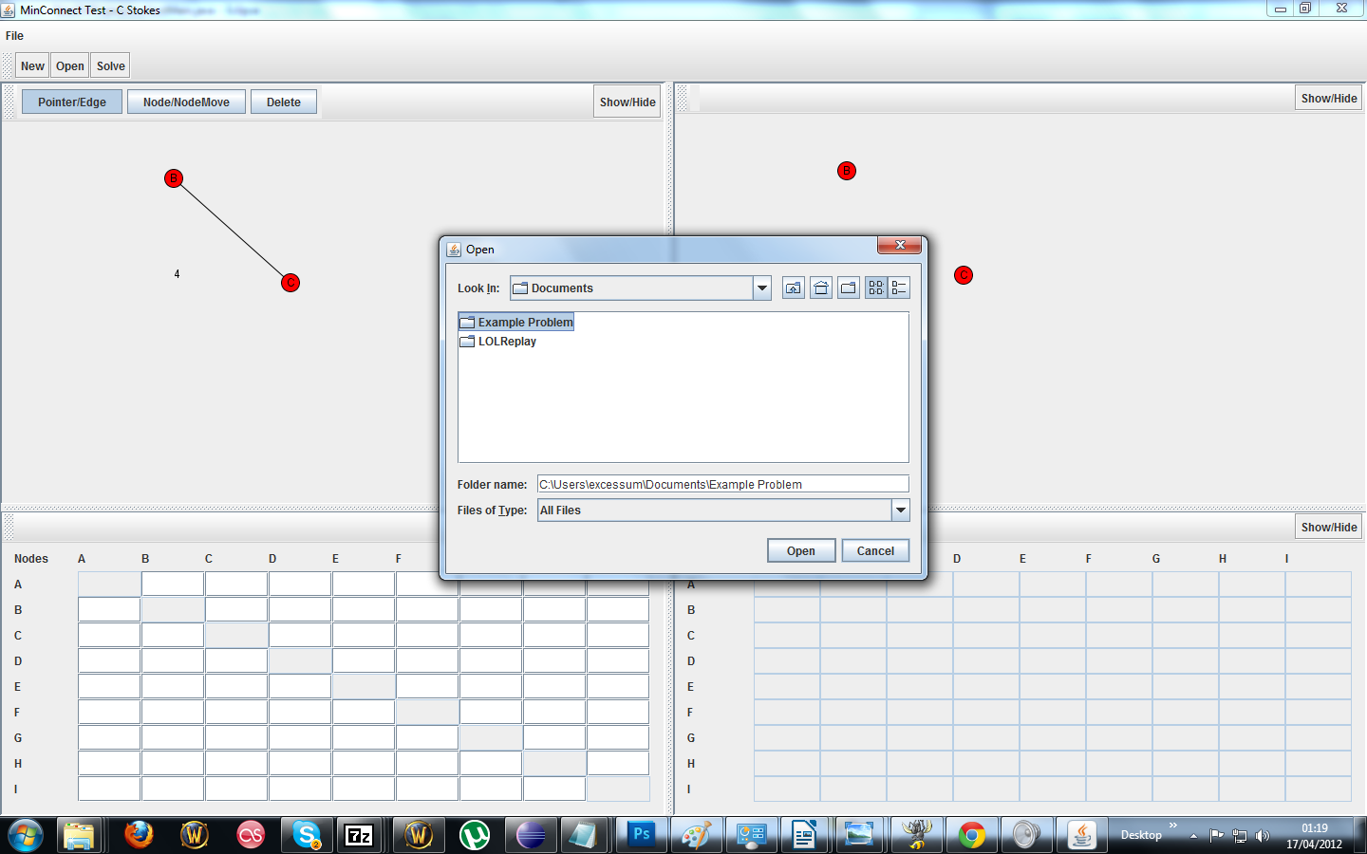

In order to open a file you have previously saved make sure to have a fresh copy of the program up with no nodes or edges drawn on, then go to file > open and select the folder in which the problem is. It will then rebuild the problem for you and you can press the solve button to get the solution again.
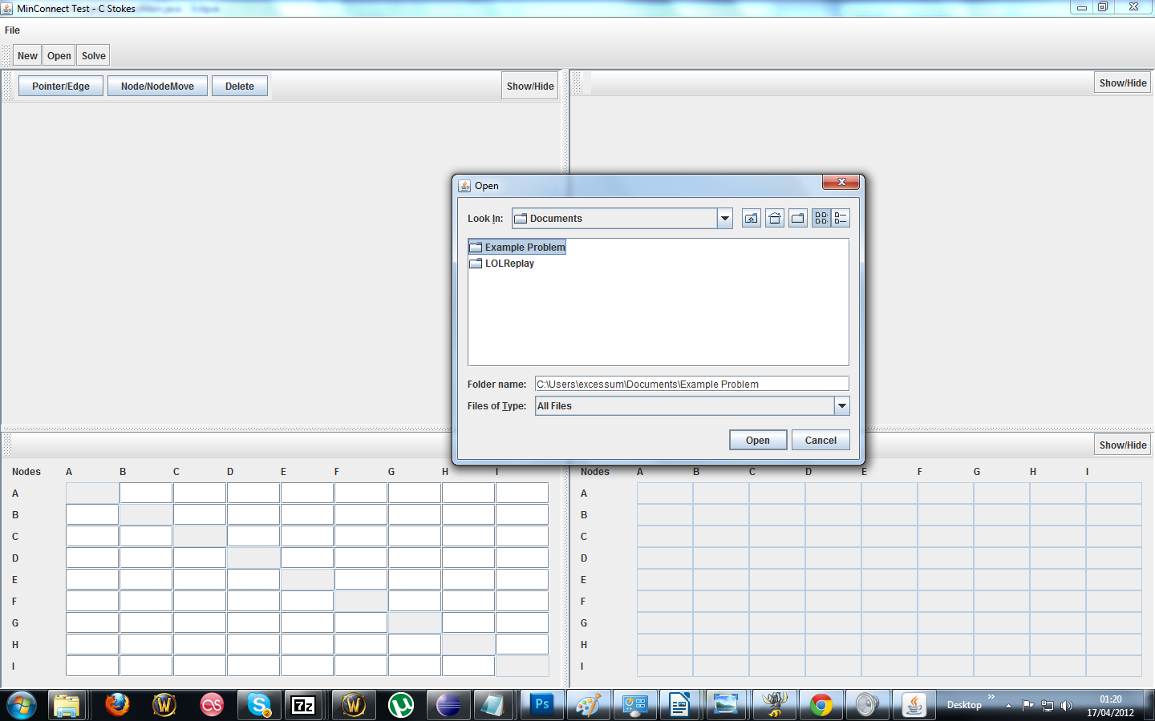

Error messages

Error | Cause | Fix
Invalid or duplicate node label entered, please enter a valid node label. | You have entered a node label that does not consist of just letters, or have entered the same node label twice. | Enter a node label that follows the rules set.
Weight entered is not an integer | You have entered an edge weight value that is not an integer value (e.g it is a decimal or not a number) | Enter a new edge weight that is an integer.

Limitations
The current build is an early version and many improvements are to come, and as such there are some features not yet implemented or fully functional, these include:
- The result table will not be displayed or generated
- The solution table will not be generated from a graph
- The minimize buttons on the table j panels do not work.
- The delete button currently serves no purpose
PLANNING TO IMPLEMENT
- Saving a problem has the same popup box and opening one

